Arduino Dimmer light circuit with timer

Smart Sun

Design Documentation

VERSION: 0.1

Author: Antonio Gordillo Guerrero
Date: 01/19/14


Contents
Desired Features 3
Previous Ideas 4
From www.instructables.com 4

Desired Features

- Control of the amount of light of a 220V lamp.

- Select the time of the dimming of the light in 24h cycles.

- Dim completely the light in case of natural light in the ambient

Previous Ideas

Electronic dimmer from www.instructables.com
http://www.instructables.com/id/Arduino-controlled-light-dimmer-The-circuit/step3/The-software-a-bit-of-theory/- From Guitar amplifier for “small” cabinet with 12'' speaker.

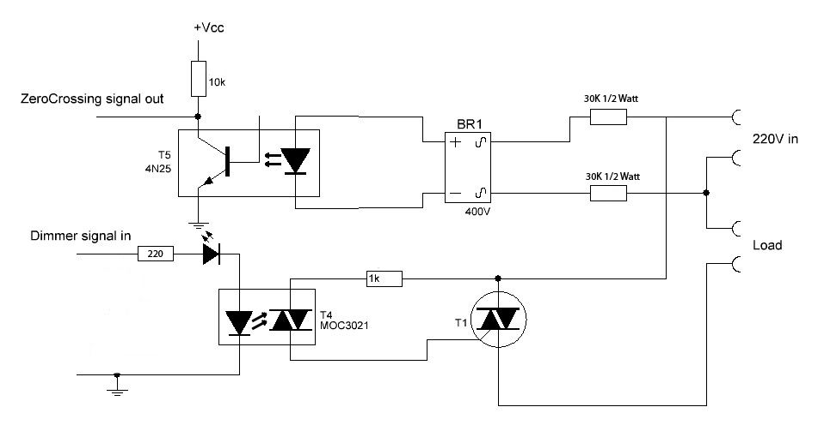

Based on zero-cross detector and pulse controlled TRIAC.

There are 2 major net frequencies in the world: 100Hz in Europe and most of Asia and Africa and 120 Hz in the America's (and parts of the Caribean). There are 2 major voltages in the world: 110-120V and 220-240V but they are not important for the mathematics here.

“For ease of use I will take the 50Hz frequency as an example:
50Hz is 50 waves per second. Each sinuswave thus takes 1000ms/50=20ms (miliseconds)
As there are 2 sinuspeaks in a wave that means that after every zero detection there is a 10ms period that we can regulate.
Should we ignite the lamp directly at the beginning of that period, the lamp will receive full power, should we do it at the end of that 10ms period the lamp will receive no ower and should we do it halfway, the lamp will receive half power.
As we are using TRIACs, what the software needs to do is to wait for the zero point at the sinuscurve, take note of that and then wait a specified amount of time within that 10ms period to send a pulse to the TRIAC.
If it sends that pulse at 5ms, the lamp will only burn at half power.”

So we will catch a zero-cross every 10ms. The Arduino Uno clock cycle is 1/16MHz = 62,5ns.

I use a interrupt-based version of the Arduino code. On Arduino Uno there are two interrupt pins. They are located in the physical pins 2 (int. 0) and 3 (int. 1)

Development
Light control as a function of environment light

I will use an LDR to measure the amount of ambient light.
In my case the LDR has 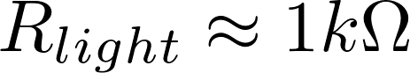 

I always measure the amount of light in the ambient.

Components

TRIAC

I use model BTA12-600: http://www.haopin.com/PDF/BTA12-600B.pdf

